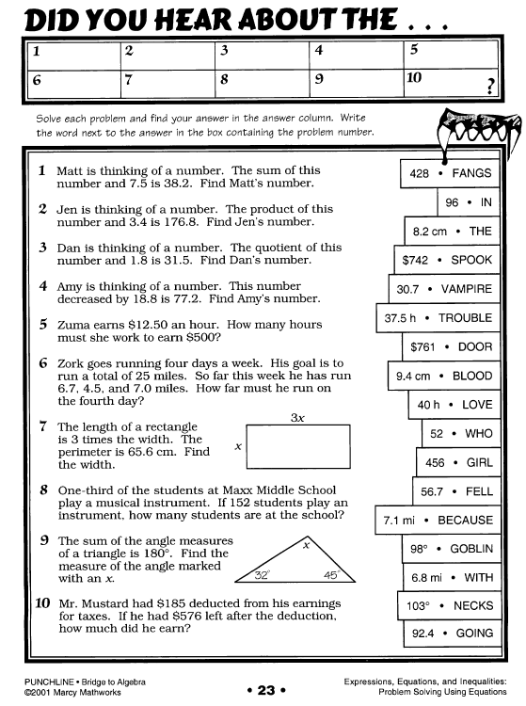
Name: ___________________________________
Directions: Write the equation for each problem. Show ALL steps to
solve for the variable. Include the “check,” by substituting your solution
back into the original equation.

