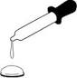
Drops on a Penny Name:_________________________

Background and Key Concepts
When water is gently dropped onto a flat surface like a penny, it stays together, forming a small drop, rather than running off the penny. This is due to surface tension, which results from water molecules being attracted to one another. As you drop more and more water on the penny, the water will form a dome shape with a curved upper surface. Eventually, however, the dome becomes too big, and the surface tension can’t hold the dome together. The water then spills off the penny’s surface. Just how strong is the surface tension of water? How many drops of water do you think a penny will hold?

Materials:
• Penny
• Water

Procedure
1) How many drops of water will fit on a penny before the water runs off? Do you think it will be different for Heads vs. Tails? Record your predictions below:

a. Which side do you think will hold MORE water? Heads Tails They’ll be equal

b. How many drops do you predict will fit on the HEADS side? ___________

c. How many drops do you predict will fit on the TAILS side? ______________

2) Share prediction data with the class and record on your sheet.

3) EXPERIMENT: Place the penny on a paper towel. Drop water onto the HEADS side of the penny using the pipette, counting the number of drops as you go. Keep dropping water and count-ing drops until the water finally runs off the penny. Then repeat, using the TAILS side of the penny.

4) Record the number of drops on your penny: HEADS _____________ TAILS________________

5) Record the class data on your sheet, ordered from greatest to least.

6) Make box plots for all 4 sets of data.

Analysis
7) What can you conclude from your data? Write a paragraph below. Include observations about the center, spread, and shape.

_____________________________________________________________________________

_____________________________________________________________________________

_____________________________________________________________________________

_____________________________________________________________________________

_____________________________________________________________________________

__________________________________________________________________________________________

Comparison of Data: Heads vs. Tails and Predictions vs. Experimental Data

Heads – Predictions

Heads – Exp. Data

Tails – Predictions

Tails – Exp. Data

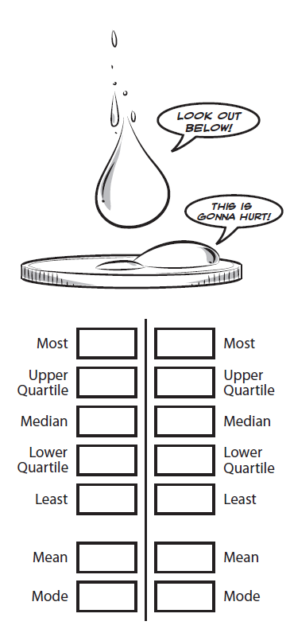
Tails – Predictions Tails –Experimental Data

Heads – Predictions Heads –Experimental Data

