Name: ______________________
Date:_________Pd. 1 2 3 4
Dot Plots: Calculating Mean, Median, Mode, and Range

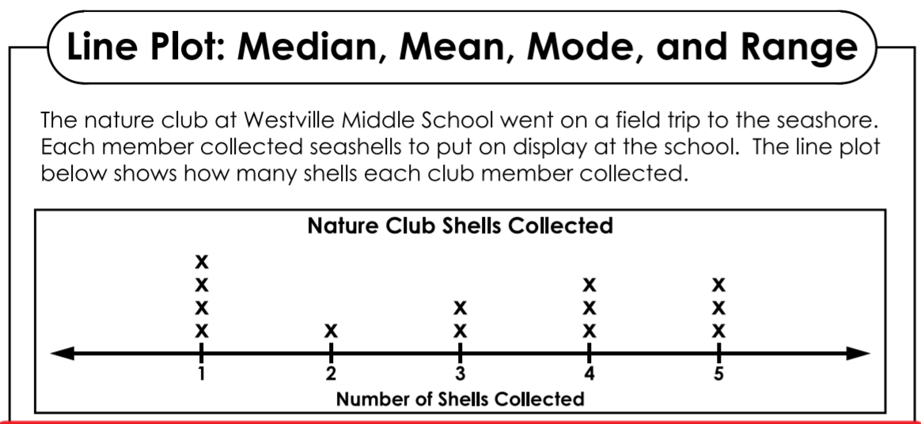
Use the data in the dot plots to answer the questions.

- What is the mean number of shells collected? ____________________

- What is the median number of shells collected?_____________________

- What is the mode? _____________________

- What is the range?______________________

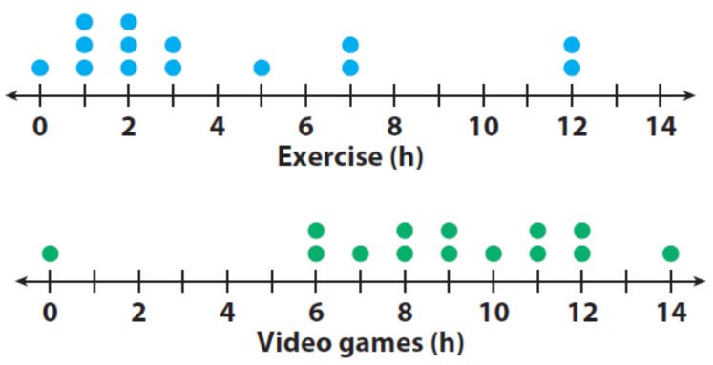
*********************************************************************************************************
Fourteen students were surveyed about the time
they spend exercising and playing video games
each week. Compare the data by answering the
questions below.

5) What is the range for the hours of exercise?_____
Playing video games?________
6) What is the mode hours of exercise?_____________ playing video games?_________________
7) What is the median hours spent exercising?__________ playing video games?_____________

8) a. What is the mean number of hours spent exercising?__________

b. What is the mean number of hours spent playing video games?_____________
