Cereal Data Activity Name:__________________________________
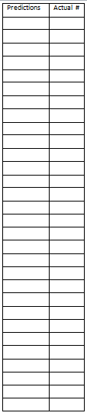
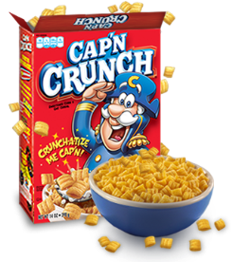
Statistical Question: How many pieces of cereal are in the typical “handful”?
Getting Started:
1) Record your class data in the table to the left.
2) Using your class data, find the measures of center:
Predictions: Actual #:
Mean = __________________ Mean = ______________________
Median = _________________ Median = _____________________
Mode = __________________ Mode = _______________________
3) Find these measures of spread:
Predictions: Actual #:
Range = __________________ Range = ______________________
MAD = ___________________ MAD = _______________________
Let’s display our data!
4-5) Create your histograms below. Make sure that you use the same scale and intervals on both number lines, so that we can correctly compare predictions with our actual data! Also, be sure to make your intervals equal. Include a title on each histogram.
Predictions

Actual Data

Explore Further!
6) What comparisons can you make between the class predictions and actual data?

7) Lebron James walks in and scoops up a handful of cereal. After entering his data, the mean increases by 5. How many pieces of cereal did he get?

8) Mrs. Bothers’ daughter, Claire, walks in and scoops up a handful of cereal. After entering her data, the range drops by 3. How many pieces of cereal were in Claire’s hand?

9) CHALLENGE!! 10 of your BFFs decide to take this cereal challenge. Their mean is 25, and their median
is 30. Give a possible set of data that could produce these measures of center.

Data Points:

