Area Notes & Practice

Area is the number of __________________ ________________ inside a ________________________. Fill in the table below.
Name of Polygon
Picture | 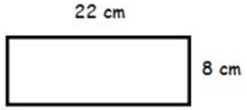 | 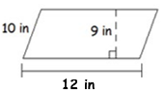 | 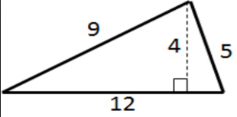 | 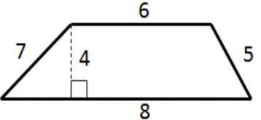
Write the formula
Substitute for the variables (Show work)
Solve. Include square units in your answer.

Area Practice Name:___________________________________

1. Fill in the Flow Map with the steps to finding the area of a shape:

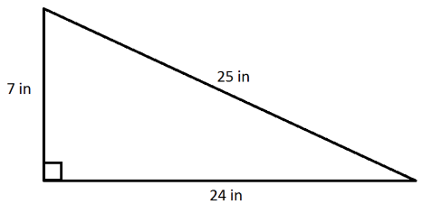
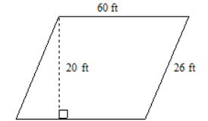
2. Find the area. 3. Find the area.

4. Find the area. 5. Find the area.
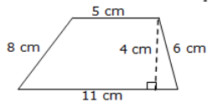
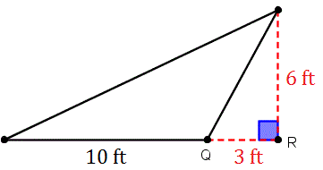

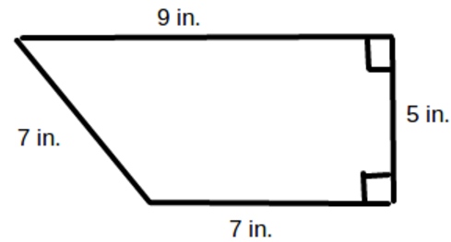
6. Find the area. 7. Find the area.
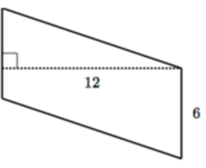

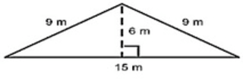
8. Read each person’s answer. If they are correct, tell how you know.
If they are incorrect, explain their mistake.
Billy Bob said the area of the triangle is 90 m². Correct / Incorrect

Silly Sally said the area is 67.5 m². Correct / Incorrect

Einstein said the area is 45 m². Correct / Incorrect

