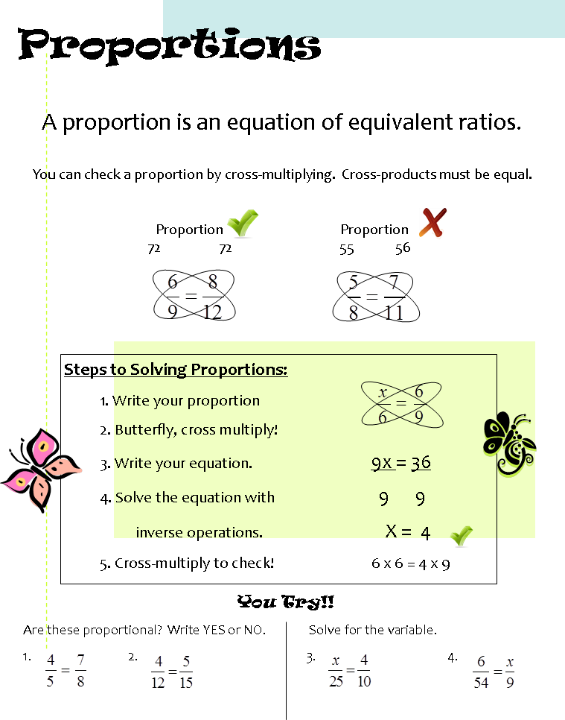
5) Sebastian can correctly solve 120 multiplication problems in 2 minutes. At this rate, how long
would it take him to solve 300 problems?

6) Alexandra types at a speed of 45 words per minute. How many words can she type in 10 minutes?

7) Daisy needs 1.5 cups of sugar to make 12 cupcakes. How much sugar does she need to make 48 cupcakes?
5) Sebastian can correctly solve 120 multiplication problems in 2 minutes. At this rate, how long
would it take him to solve 300 problems?

6) Alexandra types at a speed of 45 words per minute. How many words can she type in 10 minutes?

7) Daisy needs 1.5 cups of sugar to make 12 cupcakes. How much sugar does she need to make 48 cupcakes?

