- Net of a _______________________________
Top:_________________ Bottom:______________
Front:________________ Back:_________________
Side:_________________ Side:__________________
Add them altogether: _________________
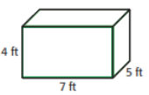
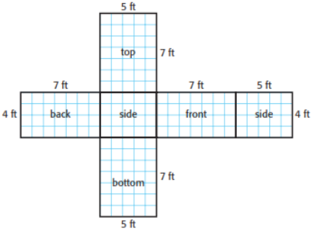 Polyhedron: ___________________________________

- Net of a _____________________________
Top:_________________ Bottom:______________
Front:________________ Back:_________________
Side:_________________ Side:__________________
Add them altogether: _________________
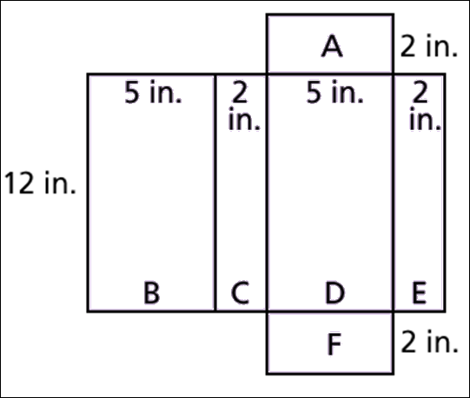

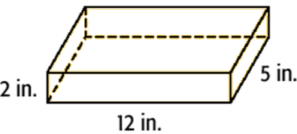

Polyhedron:__________________

3. Net of a _________________
Polyhedron:_____________
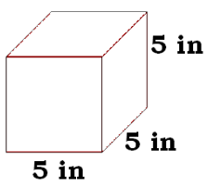

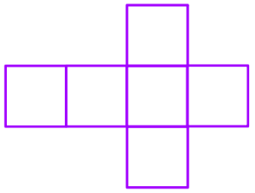
Top:_________ Bottom: _________ Front:__________ Back:_________ Side:__________ Side:__________
Surface Area = _____________________

OR: Multiply the area of ONE face by ______ because all of the side lengths are the _______________.

