~ Long Division ~

The Vocabulary: Example:

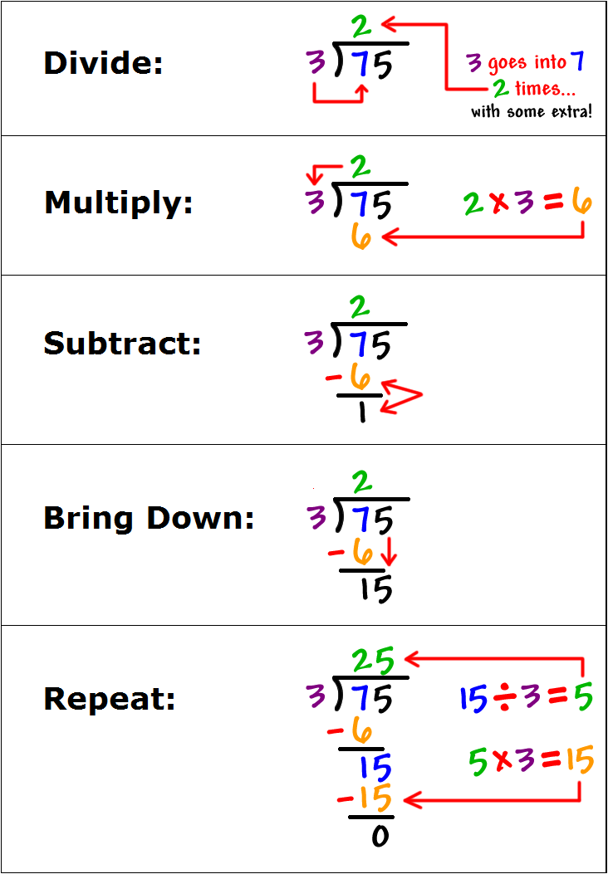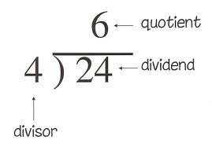

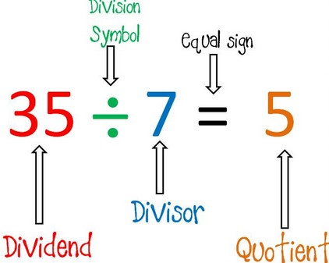



* The purpose of division is to determine how many times the ***divisor*** fits *into* the ***dividend****.*
* Division is the opposite of multiplication. ***To “undo” or check*** your

answer, you can multiply the quotient by the divisor!

~ Long Division ~

The Vocabulary: Example:







* The purpose of division is to determine how many times the ***divisor*** fits *into* the ***dividend****.*
* Division is the opposite of multiplication. ***To “undo” or check*** your

answer, you can multiply the quotient by the divisor!

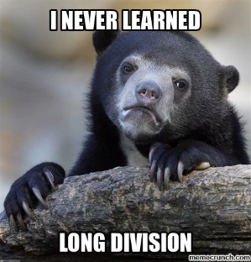~ Long Division Practice ~

1.   2) 

3) **121 ÷ 8** 4) **708 ÷ 12**

**Challenge!**

5) **7,695 ÷ 6** 6)



~ Long Division Practice ~

1.   2) 

3) **121 ÷ 8** 4) **708 ÷ 12**

**Challenge!**

5) **7,695 ÷ 6** 6)

