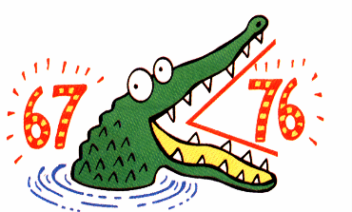
Inequalities Practice
1. Which number is a solution to the inequality below? x > 4  A. 1 B. 2  C. 4 D. 5 | 2. Which number is NOT a  solution to the inequality? x < 8  - 6 B. 7  C. 8 D. 9
3. Which statement describes “a number more than 22”?  - x < 22 B. x > 22  - x < 22 D. x > 22 | 4. Which statement describes “ a number less than or equal to 43”?  - x < 43 B. x > 43  C. x < 43 D. x > 43
5. Which statement describes “ a number no more than 17”?  A. x < 17 B. x > 17  C. x < 17 D. x > 17 | 6. Which statement describes “at least 32”?  - x < 32 B. x > 32  C. x < 32 D. x > 32
7. Which number is a solution to x + 4 > 12  - 3 B. 5  C. 7 D. 9 | 8. Which number is NOT a solution to  x – 3 < 10  - 7 B. 8  - 10 D. 14
9. Which number is a solution to  3x > 12  - 4 B. 5  - 2 D. 3 | 10. Which number is NOT a solution to  2x < 10  - 3 B. 4  - 5 D. 6
11. Which inequality matches the graph below?  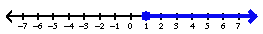 | 12. Which inequality matches the graph below?  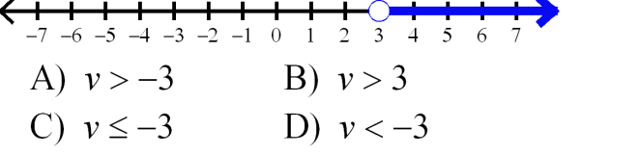
Inequalities Practice
1. Which number is a solution to the inequality below? x > 4  A. 1 B. 2  C. 4 D. 5 | 2. Which number is NOT a  solution to the inequality? x < 8  - 6 B. 7  C. 8 D. 9
3. Which statement describes “a number more than 22”?  - x < 22 B. x > 22  - x < 22 D. x > 22 | 4. Which statement describes “ a number less than or equal to 43”?  - x < 43 B. x > 43  C. x < 43 D. x > 43
5. Which statement describes “ a number no more than 17”?  A. x < 17 B. x > 17  C. x < 17 D. x > 17 | 6. Which statement describes “at least 32”?  - x < 32 B. x > 32  C. x < 32 D. x > 32
7. Which number is a solution to x + 4 > 12  - 3 B. 5  C. 7 D. 9 | 8. Which number is NOT a solution to  x – 3 < 10  - 7 B. 8  - 10 D. 14
9. Which number is a solution to  3x > 12  - 4 B. 5  - 2 D. 3 | 10. Which number is NOT a solution to  2x < 10  - 3 B. 4  - 5 D. 6
11. Which inequality matches the graph below? | 12. Which inequality matches the graph below?
13. Which inequality matches the graph below?  - x > 3 b. x > 3  - x ≤ 3 d. x ≥ 3 | 14. Which inequality matches the graph below?  - n < 0 b. n ≤ 0  c. n ≥ 0 d. n > 0
15. Solve x + 11 > 19 | 16. Graph the solution to the inequality from question #15.
17. Solve x – 3 < 5 | 18. Graph the solution to the inequality from question #17.
19. Solve 3x < 12 | 20. Graph the solution to the inequality from question #19.
21. Solve $\frac{x}{4}$ > 2 | 22. Graph the solution to the inequality from question #21.
23. Write an inequality for this statement “x is less than or equal to 7”. | 24. Write an inequality for this statement  “x is greater than -9”
13. Which inequality matches the graph below?  - x > 3 b. x > 3  - x ≤ 3 d. x ≥ 3 | 14. Which inequality matches the graph below?  - n < 0 b. n ≤ 0  c. n ≥ 0 d. n > 0
15. Solve x + 11 > 19 | 16. Graph the solution to the inequality from question #15.
17. Solve x – 3 < 5 | 18. Graph the solution to the inequality from question #17.
19. Solve 3x < 12 | 20. Graph the solution to the inequality from question #19.
21. Solve $\frac{x}{4}$ > 2 | 22. Graph the solution to the inequality from question #21.
23. Write an inequality for this statement “x is less than or equal to 7”. | 24. Write an inequality for this statement  “x is greater than -9”

