Student Name: ______________________________Pd: 3
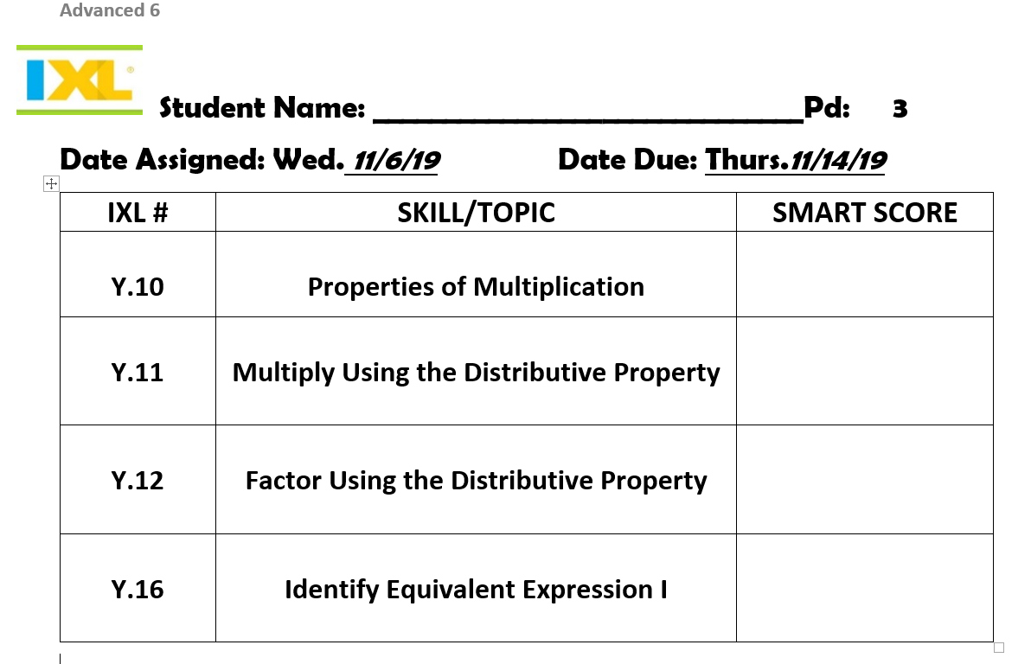
Date Assigned: Wed. 11/6/19 Date Due: Thurs.11/14/19
IXL # | SKILL/TOPIC | SMART SCORE
Y.10 | Properties of Multiplication
Y.11 | Multiply Using the Distributive Property
Y.12 | Factor Using the Distributive Property
Y.16 | Identify Equivalent Expression I

